Simple Manual for Image Annotating Tool
If you are able to read C# code, it would be great for me because you can figure out how to use the tool directly by going through the code. But it’s helpful for though who need some more time to learn C# and software engineering. Here I will write down a simple manual for you:
When you run the SampleCropor.exe, you will see such user interface:
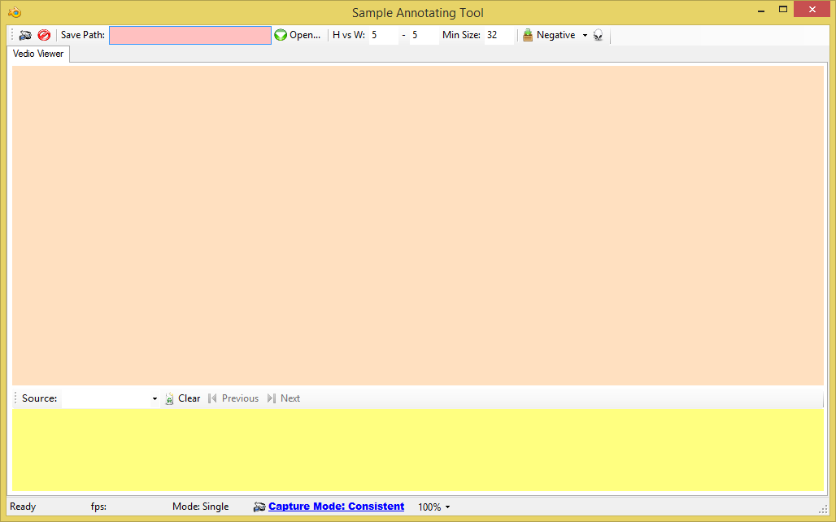

1, Select a target forlder to save your data by clicking
2, Load image to the pogram by dragging image to the orange region under tab “Vedio Viewer”, the program only support several formats, JPG, BMP, PNG and so on, if some of you image can’t be loaded via dragging, please change their format and try again.
3,Try to right click the image you just loaded, you wil find a red rectange will show or hide when you click. If it is visible, you can press “ALT” key to save the sub image inside that rectangle to you target folder which you need to check. Then you can drag the rectagne any where you like and repeat pressing “ALT” to get more sample images.
4, If you press “Ctrl” or click (sometime you may find nothing happen when you click that button, then click it again, there is something wiered with C#), the program will automatically generates lots of nagetaive images using the currently loaded image. You are encourage to try it and check the change in target folder. I believe you will learn how to use is very soon.
5, The program also support to generate negative sample over a sub region of that loaded image. You can pick a ROI(Region of Interest) by moving and scaling the rectange, and then click the arrow 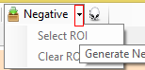, and you will see a menu item called “Select ROI” and another one to clear it. If you click the first one, the program will sample negative images within that region, which is useful when you want to rule out some region.
6, There are some other fucntions which I think is kind of trivial, but you can find them if you know C#. But please try to develop a tool you like to use, that is very helpful for you to improve your programming skills.

Chunde Huang
8/19/2014 11:44:14 AM

